Bison |  | Bison
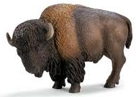
2 tomahawks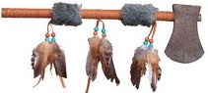  1 couteau 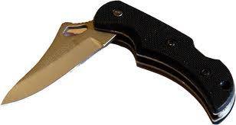 |  | 2 tomahawks  1 couteau
10 pierres 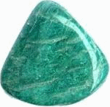 |  | 10 pierres 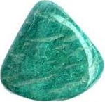
Bison |  | Bison
2 tomahawks  1 couteau |  | 2 tomahawks  1 couteau
10 pierres |  | 10 pierres
Orignal |  | Orignal
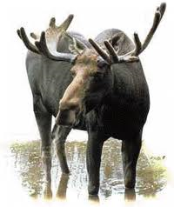
1 tomahawk  1 lance 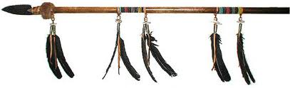 |  | 1 tomahawk  1 lance
8 pierres |  | 8 pierres
Orignal |  | Orignal
1 tomahawk  1 lance |  | 1 tomahawk  1 lance
8 pierres |  | 8 pierres
Chevreuil |  | Chevreuil
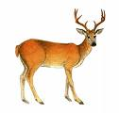
1 arc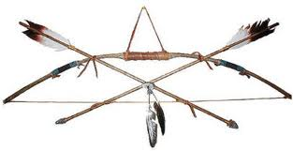  4 flèches 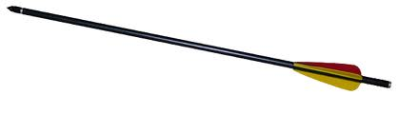  1 couteau |  | 1 arc  4 flèches  1 couteau
7 pierres |  | 7 pierres
Chevreuil |  | Chevreuil
1 arc  4 flèches  1 couteau |  | 1 arc  4 flèches  1 couteau
7 pierres |  | 7 pierres
Renard |  | Renard
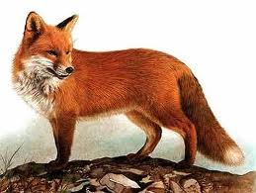
2 lances |  | 2 lances
6 pierres |  | 6 pierres
Renard |  | Renard
2 lances |  | 2 lances
6 pierres |  | 6 pierres
Castor |  | Castor
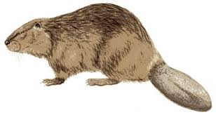
1 lance  1 couteau |  | 1 lance  1 couteau
5 pierres |  | 5 pierres
Castor |  | Castor
1 lance  1 couteau |  | 1 lance  1 couteau
5 pierres |  | 5 pierres
Lièvre |  | Lièvre
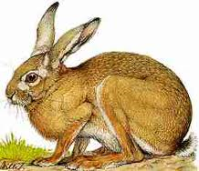
2 pièges 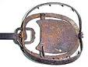  1 couteau |  | 2 pièges  1 couteau
4 pierres |  | 4 pierres
Lièvre |  | Lièvre
2 pièges  1 couteau |  | 2 pièges  1 couteau
4 pierres |  | 4 pierres
Perdrix |  | Perdrix
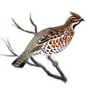
1 arc  2 flèches |  | 1 arc  2 flèches
4 pierres |  | 4 pierres
Perdrix |  | Perdrix
1 arc  2 flèches |  | 1 arc  2 flèches
4 pierres |  | 4 pierres

